CVI620 – Assignment 2
Fall 2025

Total Mark: | 7.5 marks (7.5% of the total course grade)
Submission file(s): | - Python files for train and inference
Deadline | - November 27th, 2025

If you are unable to complete the assignment on-time for any legit reason, please provide documentation explaining your absence (e.g., an appointment confirmation or a work letter).

Please submit the submission file(s) through Learn@Seneca. Make sure to use GitHub and provide the link to your GitHub account for all your contributions in the box below:
Project GitHub repository: | https://github.com/avinav456/CVI620_Assignment2

Please attach some of your test images along with any required explanations in this document.

- For the Cat and Dog dataset provided in the Q1 folder, perform classification using all the methods you know and try to achieve the best possible result. Compare the algorithms carefully and tune the parameters so that the best result can be obtained.
Save the trained model and test it on several images from the internet. Was the model able to correctly predict the images?

Ans 1: Four classification methods were implemented on the Cat and Dog dataset: K-Nearest Neighbors (KNN), Logistic Regression, Convolutional Neural Network (CNN), and Stochastic Gradient Descent (SGD) Classifier. The CNN classifier demonstrated the highest performance with 64.2% accuracy. Additionally, the trained CNN model was tested on several images downloaded from the internet and successfully classified them. Screenshots of each method's results are provided below.

Logistic regression:
Accuracy:60%

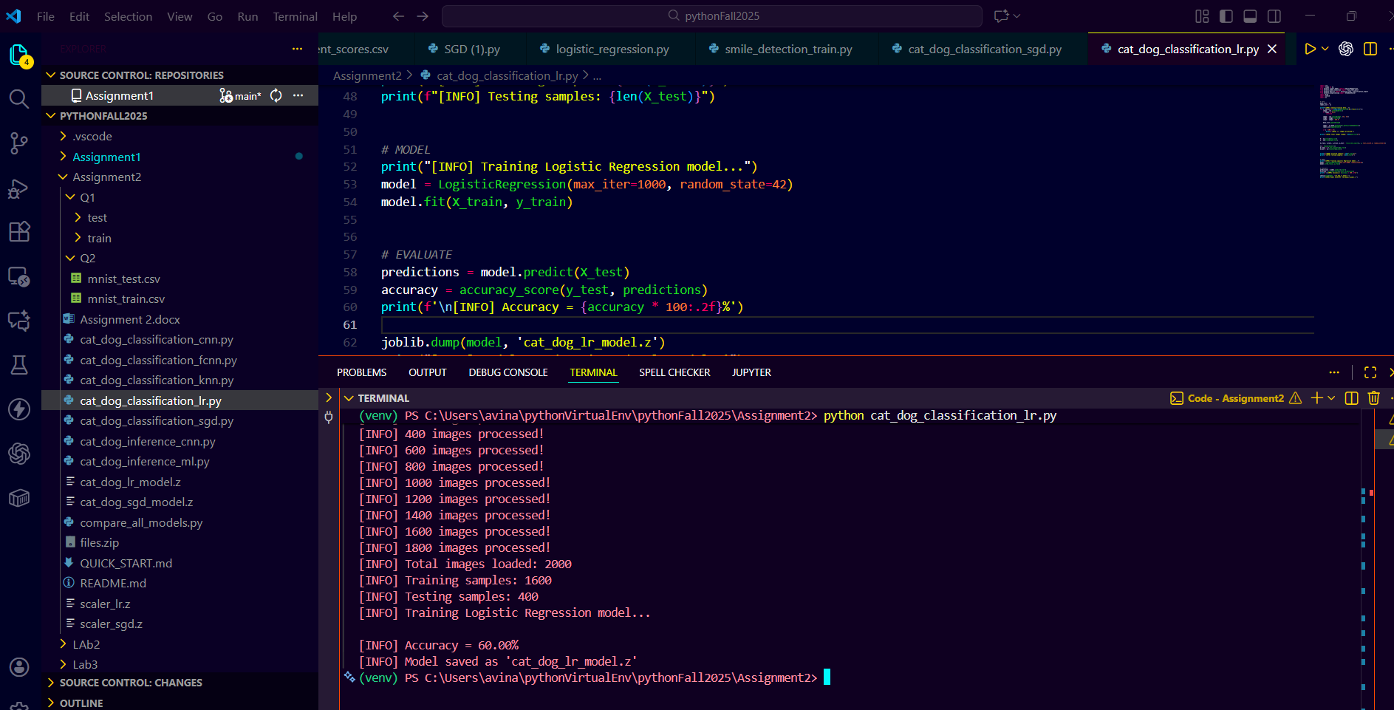

SGD Classifier:
Accuracy: 59%

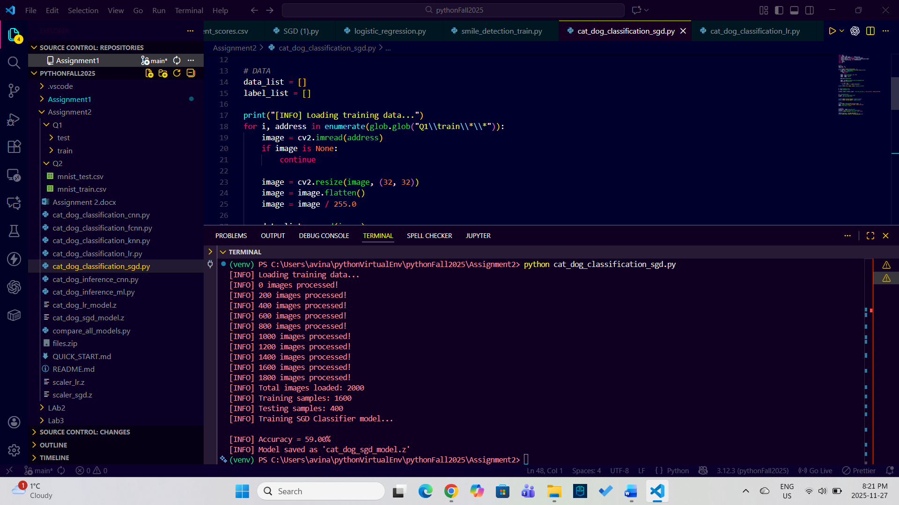

KNN classifier:
Accuracy:55.75%

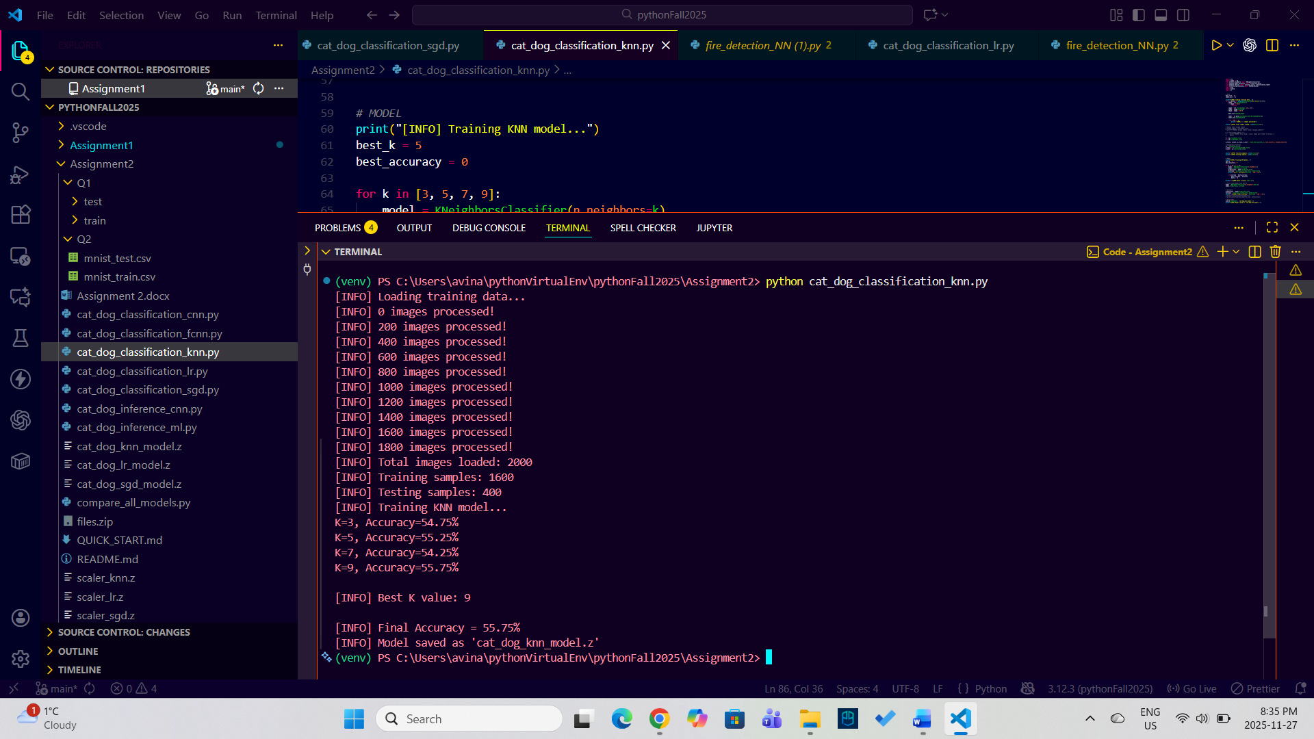

CNN classifier:
Test Accuracy:64.2%
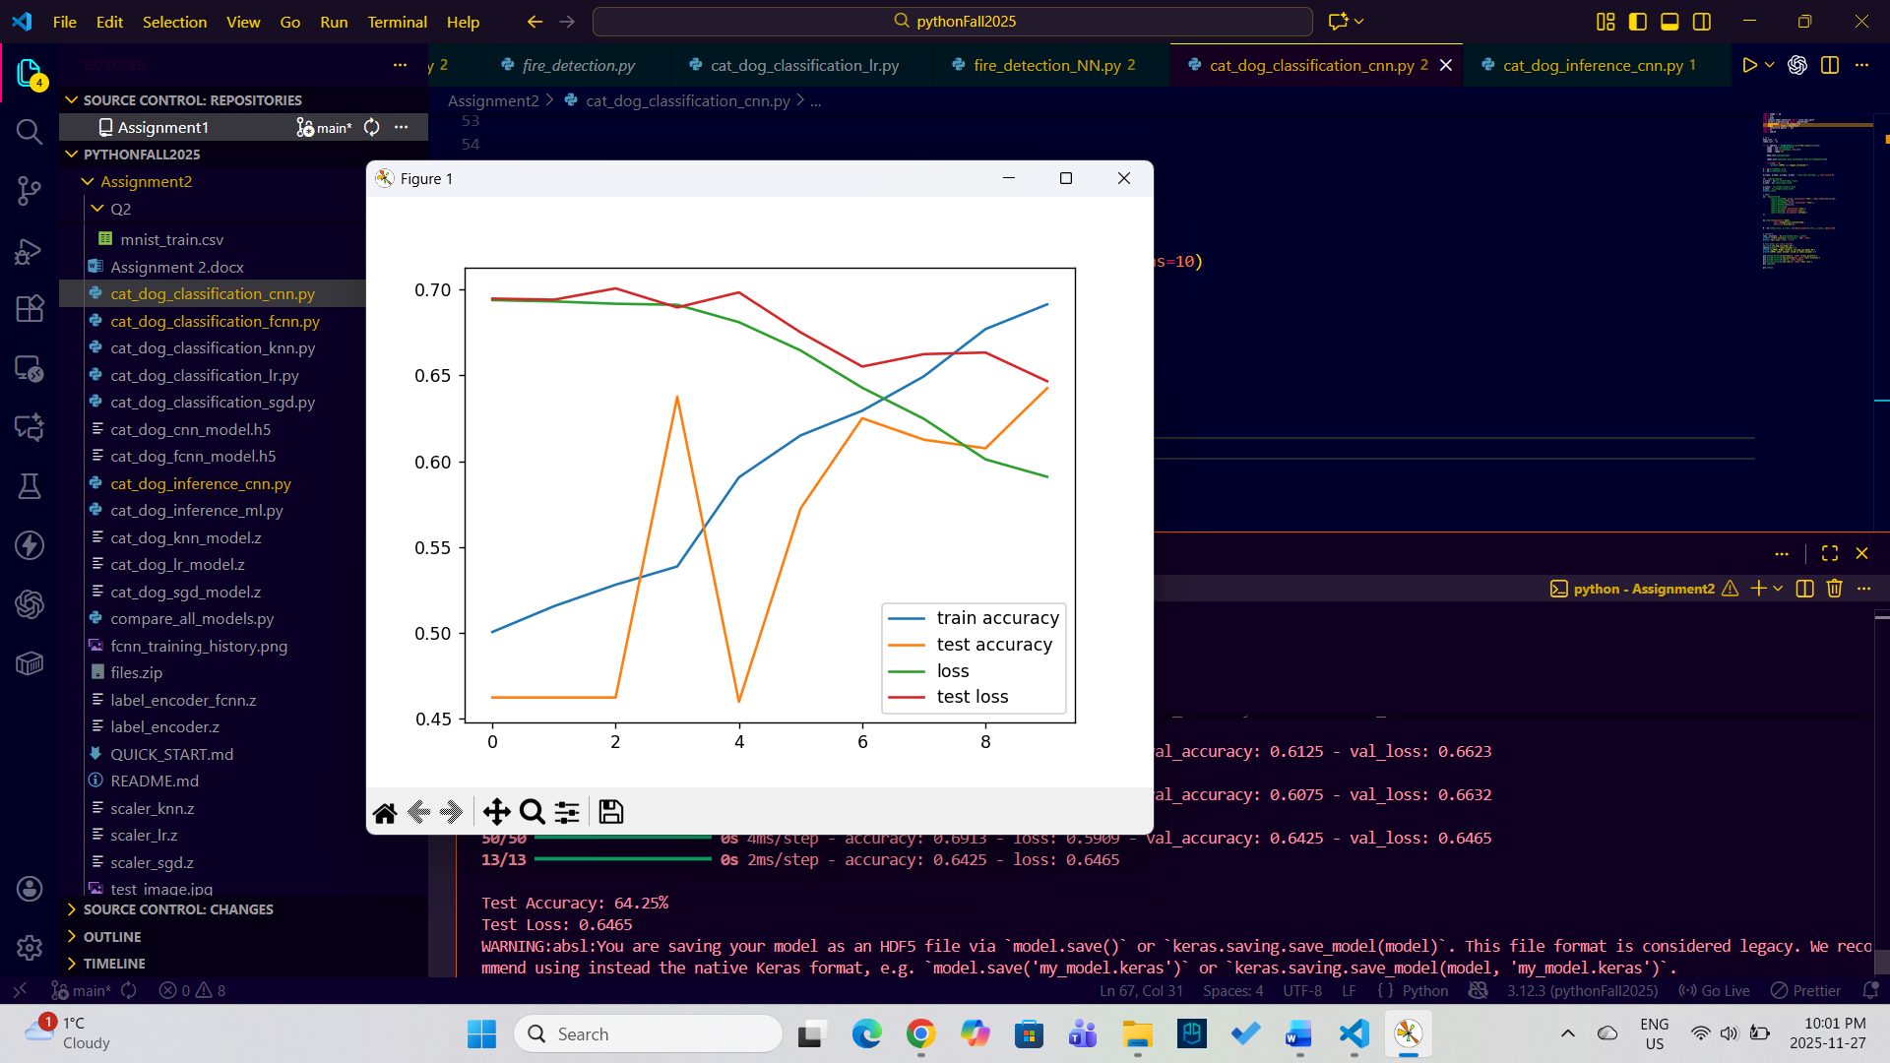
Predicting the dog the image :
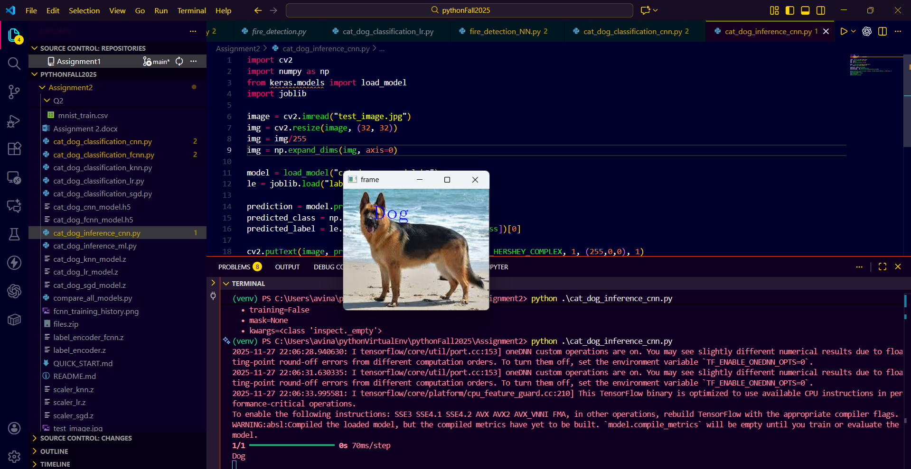

Predicting the cat image :
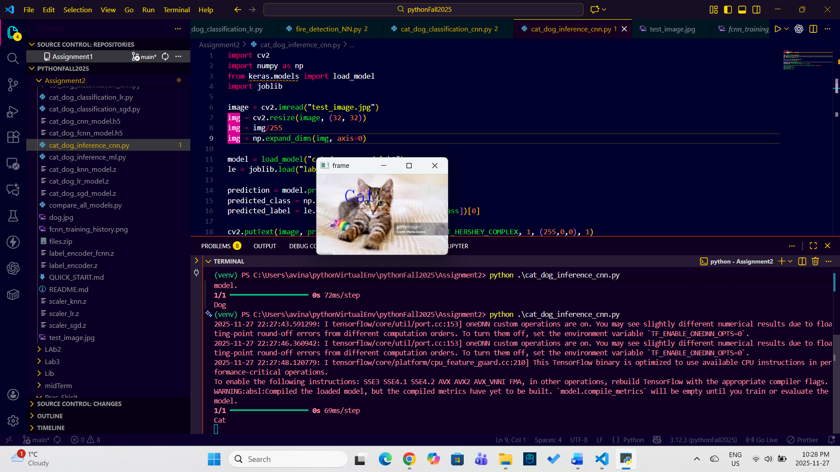
- The MNIST dataset is one of the most well-known datasets in the field of image processing. It contains 60,000 images related to handwritten digits from 0 to 9 and is provided as a CSV file in the Q2 folder. In this file, each image is represented as a flattened vector. Classify this dataset using different methods and try to achieve at least 90% accuracy.
Ans2: Four classification methods were implemented on the MNIST dataset: K-Nearest Neighbors (KNN), Logistic Regression, Convolutional Neural Network (CNN), and Stochastic Gradient Descent (SGD) Classifier. All four algorithms achieved over 90% accuracy, with the CNN classifier demonstrating the highest performance. Screenshots of each method's results are provided below.
KNN classifier:
Accuracy: 94.38%
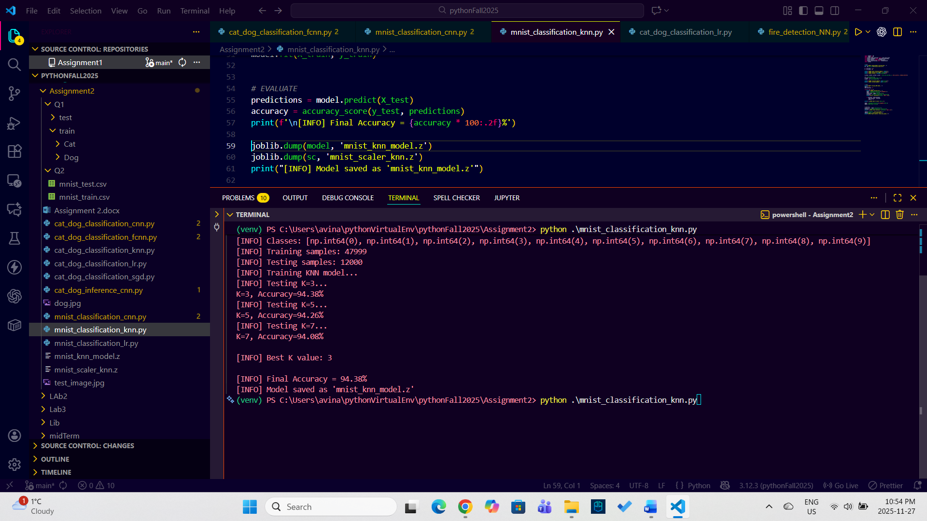

Logistic regression:
Accuracy: 91.30%
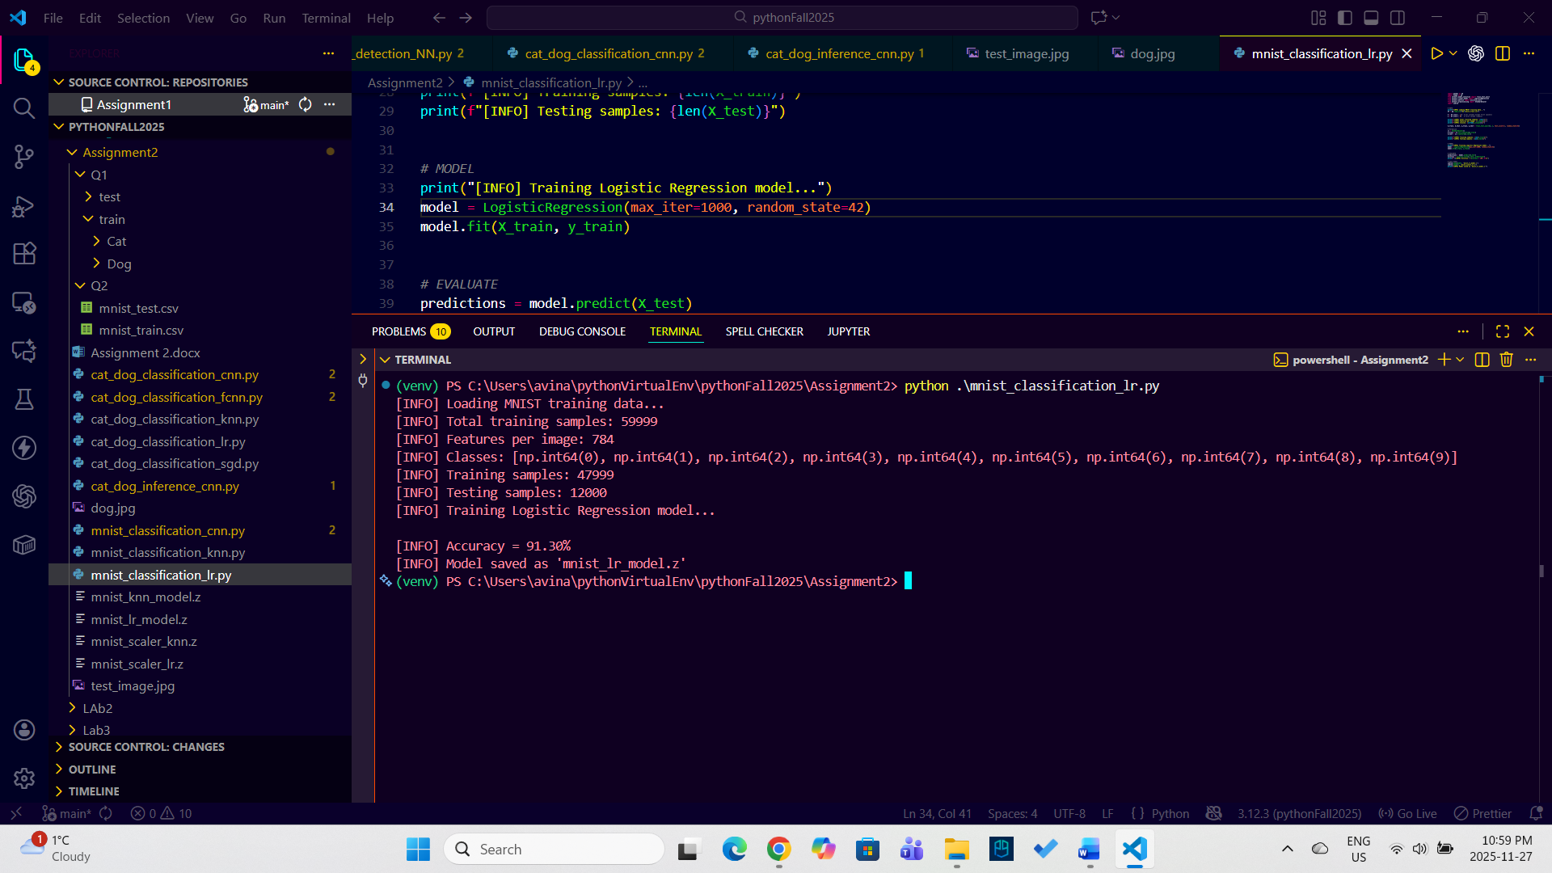

CNN classifier:
Accuracy: 98.83%

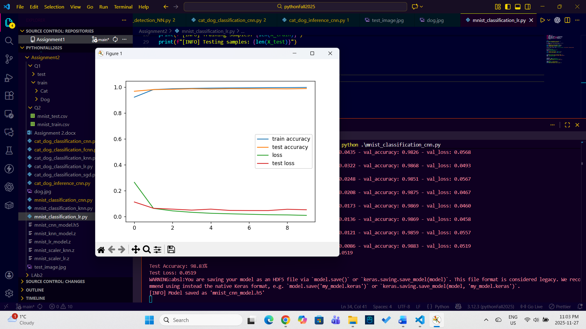

SGD classifier:
Accuracy : 90.88%

